1. **Introduction:**

The website I created entitled “Wanderful World” is a travel inspiration site that aims to give its users an idea of where to travel next. “Wanderful World” is a word play of the word “Wander” or in other term – “to travel”. Some other existing sites already provide this service like travelgowhere.com. This simple site is just a subset of what is already provided in travelgowhere.com. One thing that must be improved in this site is implementing a better database solution as currently all data are stored in an external JSON file.

I think partly why I chose to create this website is due to the first assignment of the class where we created like a travel agency site. Also, I’ve been meaning to curate my travel photos I collected throughout my travels as you will see in the different sections of this website.

The theme I chose to implement is minimalist but still playful and striking. I tried to get inspiration from existing designs in the web and got what I was looking for in this site <https://visme.co/blog/website-color-schemes/>.

1. **Website Layout:**

I used multiple layout techniques throughout the website – float, grid, flex which I think is one of the most challenging parts of making this site as it is quite tricky to implement layouts especially when you are not yet an expert. Overall, I would say that I tried my best to make the pages look as pleasing as possible and make it responsive enough. I specifically selected Iphone SE, Ipad Air Mini, Ipad Pro and a wide desktop as my main test devices for checking the display and layout of the pages.

The following are the general page layouts:

[1] Landing Page

The landing page is straightforward with a navigation bar on top section in the middle and footer on the bottom. The navbar and footer are consistent across all the pages. The body section has an image background (Paris Arc de Triomphe), a headline and a sub-headline text. A video is also attached using iframe object.

Layout:

1. Grid with 1 column – for navbar, section and footer
2. Flex left justify and center aligned – for hero section (headline, headline subtext and iframe video)
3. Flex space-between – website logo and nav links

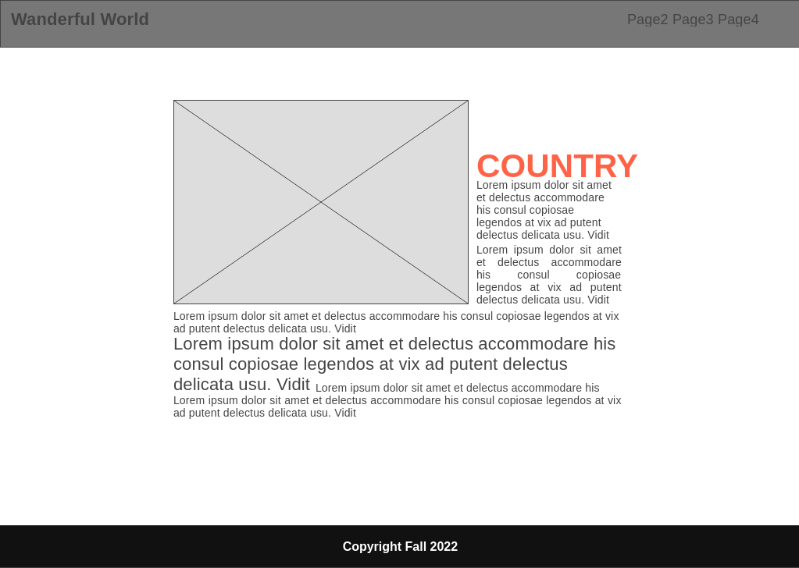[2] Page 2 “Take Me Somewhere” page

The second page is where the information in the country is displayed together with an image slider containing varying number of photos. This page can be loaded with random content or with targeted content (in case the URL has query parameter country included).

The country, leading character of the description and quote are accented through larger font size and accent colors. Image sliders are loaded depending on which country is being displayed.

Layout:

1. Slider is floated left in larger screen and respects auto flow when in smaller screen.
2. Span classes are implemented to accentuate headline, leading character of paragraph and the quotation in the middle part of the paragraph

[3] Page 3 “Browse” page

The third page is like a photo gallery where you’ll be able to see all countries and choose to “Read More” about it which will redirect to Page 2 if clicked. Hover (on desktop) and onClick (touch devices) events are implemented on the photo cards. The general layout is a flex row wrap which is responsible for the responsiveness of it on smaller devices.

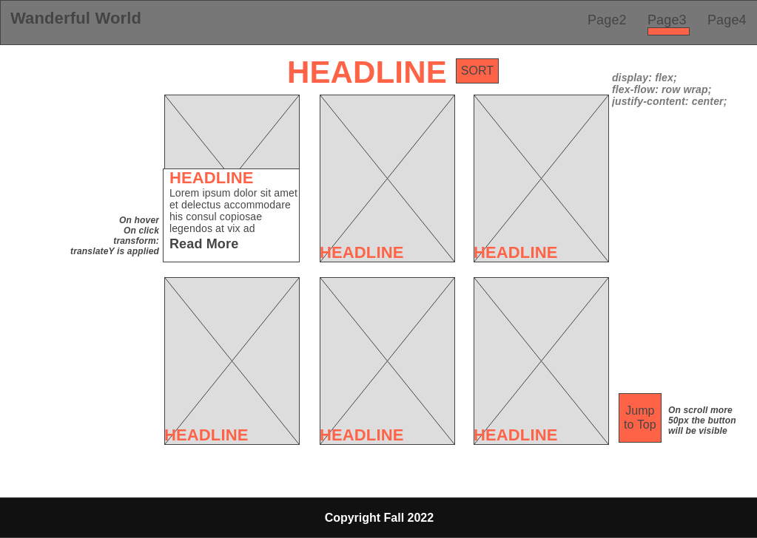

[4] Page 4 “Read Stories” page

This page has two parts - form and the comments/stories grid.

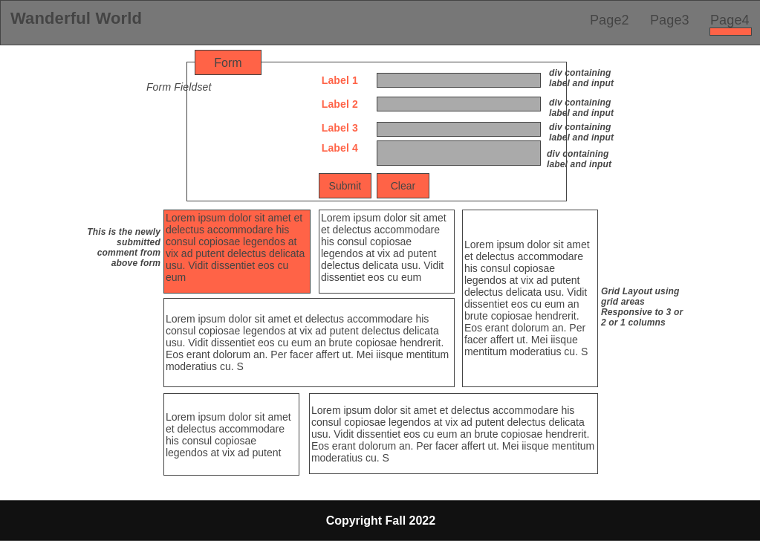First area is a form with a fieldset and each label/input pair is contained in a div and display is flex which is also responsive on smaller screen sizes.

The second area which contains the stories are in a grid layout using predefined grid areas. One limitation of it is that it can only contain a maximum of **11** comments as the grid area is defined like that and there’s no “next page” mechanism yet.

The grid area is defined in constants.js since I need to make the grid dynamic when there is a new comment from the user.

1. **Website Organization:**
2. Index.html
   1. What is it? – It is a landing page
   2. Content and Purpose – attract user to use the application
   3. Features implemented – navbar, layout and positioning, iframe video embedding, linear gradient background image to reduce the brightness of the bg image
3. Take Me Somewhere
   1. What is it – one page summary of specific country.
   2. Content and Purpose - It gives the comprehensive details of the country.
   3. Features implemented
      1. Utilizes margin left specifically to fit the active slide on the container div
      2. Utilizes label that will focus on the radio input and is vital for the dynamic selection of active slide
      3. Populating the content based on url parameter query. If country is passed as a parameter to the url, then the content for that country will be displayed. Else, choose a random country from the list.
      4. External JSON file fetch – since this website doesn’t have any database like SQL, I needed to find a way to store data in an external file as it is quite ugly to put everything in the html files.
      5. Page loading optimization – had to resize a couple of image so it will load much faster
4. Browse
   1. What is it – image gallery of the countries
   2. Content and Purpose – give the user the option to select from the available countries in the “pseudo-database”
   3. Features implemented
      1. css animation through height, bottom and opacity properties
      2. same with page 2, retrieve all information from the pseudo-database
      3. sort feature – that takes all child nodes of parent div and rearrange the child nodes based on a sorted or unsorted array of countries
      4. jump to top – simple mechanism to return to top easily
5. Read Stories
   1. What is it – page to read existing stories from past users (in this case predefined dummy comments)
   2. Content and Purpose – user can read and as well as write and dynamically see the inputted data
   3. Features implemented
      1. Grid and grid areas
      2. Form validation
      3. Emoji rating – rating the experience through emoji labels which will select a radio input behind
      4. A lot of formatting and styling to make it beautiful in any device. 😊
6. **Content Declaration:**
7. Video - <https://vimeo.com/283265177> Credits: Guy Trefler
8. Images – all images/photos in this website are taken by me.
9. Content – text content is extracted from the following resources
   1. Spain - <https://www.nomadicmatt.com/travel-guides/spain-travel-tips/>
   2. Thailand - <https://www.twowanderingsoles.com/thailand-travel-tips>
   3. France - <https://www.nomadicmatt.com/travel-guides/france-travel-tips/>
   4. Japan - <https://www.willflyforfood.net/category/barefoot-bohemian/japan/>

<https://www.willflyforfood.net/tokyo-travel-guide/#places-to-visit>

* 1. South Korea - <https://www.bucketlistly.blog/posts/two-weeks-south-korea-backpacking-itinerary#seoul-4-nights>

<https://www.willflyforfood.net/the-first-timers-travel-guide-to-seoul-south-korea/>

* 1. Belgium - <https://www.nomadicmatt.com/travel-guides/belgium/>
  2. Italy - <https://www.nomadicmatt.com/travel-guides/italy-travel-tips/>
  3. Czech Republic - <https://www.nomadicmatt.com/travel-guides/czech-republic-travel-tips>
  4. Germany - <https://www.nomadicmatt.com/travel-guides/germany-travel-tips/>
  5. Poland - <https://www.nomadicmatt.com/travel-guides/poland-travel-guide/>
  6. Switzerland - <https://www.nomadicmatt.com/travel-guides/switzerland-travel-tips/>

1. **Highlights:**

There are a few challenges I encountered while I was building this site especially since it is my first time to build such an application. I spent a lot of time making it beautiful by playing around typography, colors, positioning and layout. I also put in a lot of effort in adding dynamic content in the website. If I would pick my top 3 it would be:

1. Displaying content at random when query parameters are not present in the url (Use case: When clicking Read More from Browse and will be redirected to Take Me Somewhere)
2. Fetching data from JSON file – I had to understand promises and futures and how to access the object on promise instance using then function. I also had to learn and practice a lot of anonymous function and arrow function which are new to me
3. Responsive typography and usage of calc/var and clamp functions in css – made a whole lot better in assigning colors and having fluidity in the text sizes.
4. **Links:**
5. Github repository: <https://github.com/atibayan/atibayan.github.io>
6. Published site: <https://atibayan.github.io>
7. **References:**
8. https://masteringjs.io/tutorials/fundamentals/global-variable //const vs var
9. https://www.w3schools.com/css/css3_gradients.asp // linear gradient
10. https://visme.co/blog/website-color-schemes/ // color themes
11. https://coder-coder.com/z-index-isnt-working/ // z-index
12. https://stackoverflow.com/questions/8652462/how-can-i-send-an-element-to-the-background // send hidden radio button back
13. https://www.kirupa.com/html5/emoji.htm //emojis in javascript
14. https://www.w3schools.com/charsets/ref_emoji.asp //emojis in html

Please see the rest of references on docs/references.txt as it is too long to put here.